**Deploying a Highly Available Web Application and Bastion Host in AWS**

**================================**

1. **VPC creation:**

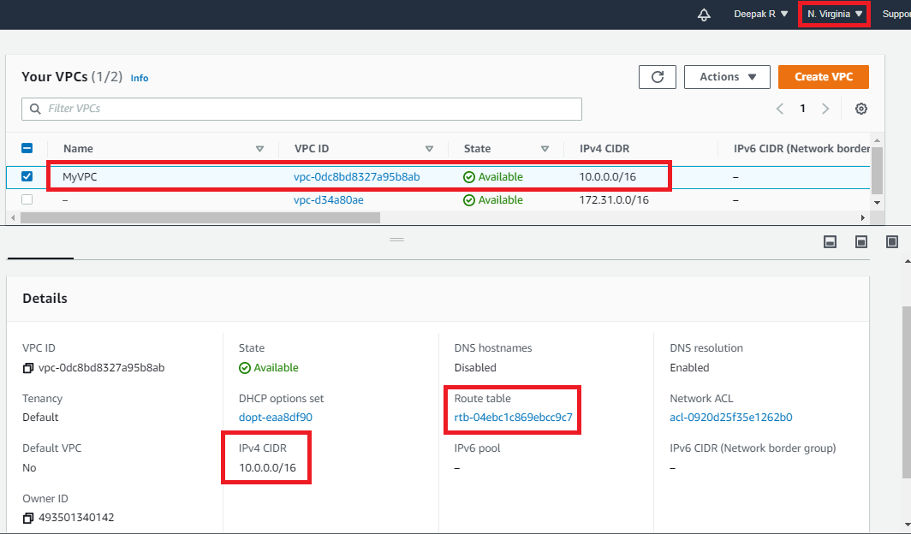

Fig. 1 VPC created

1. **Internet Gateway creation:**

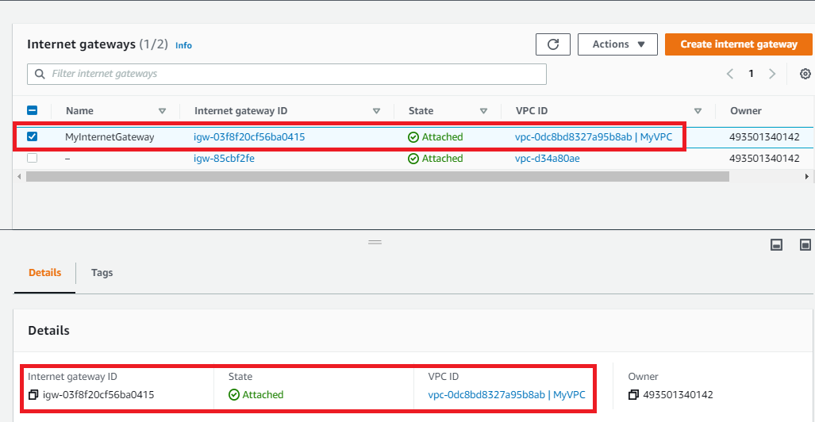

Fig. 2 Internet gateway created

1. **NAT Gateway creation:**

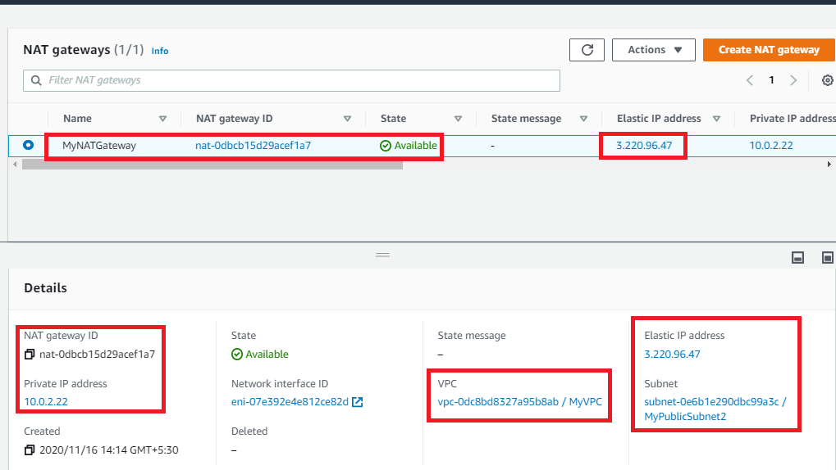

Fig. 3 NAT gateway created

1. **Subnet creation:**

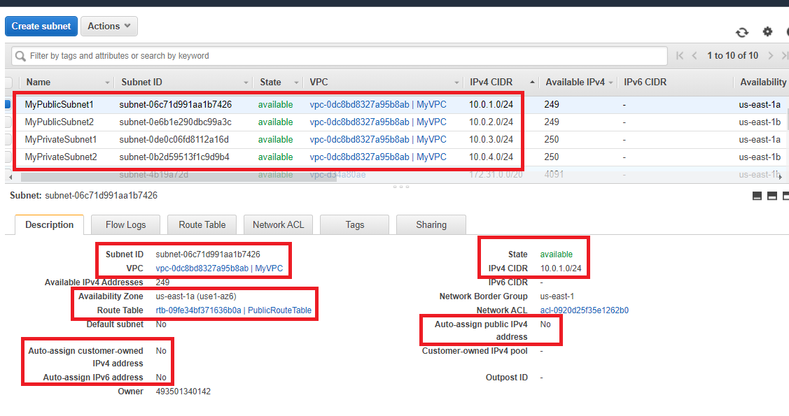

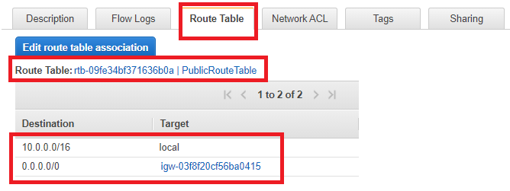

Fig. 4.1 Public Subnet 1

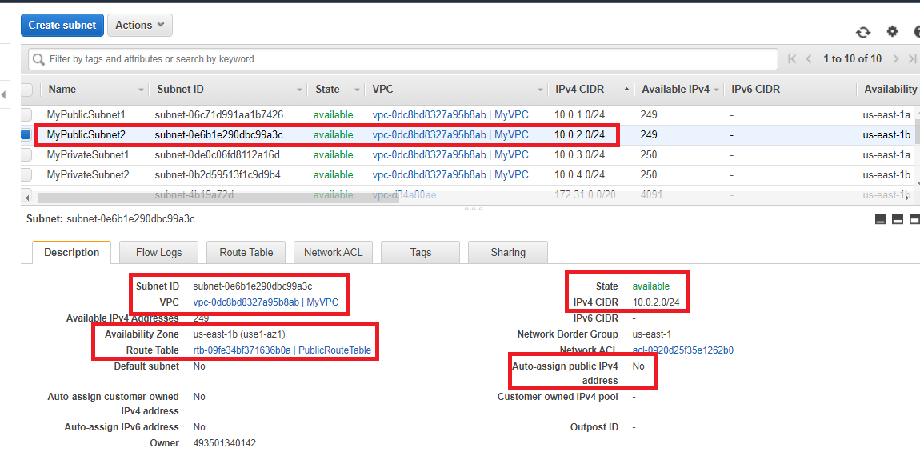

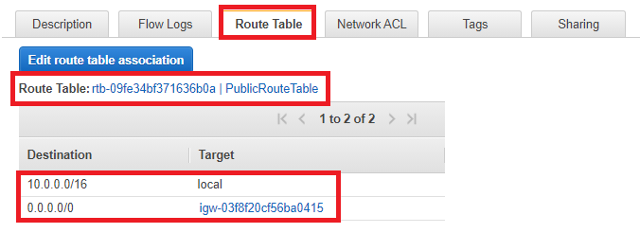

Fig. 4.2 Public Subnet 2

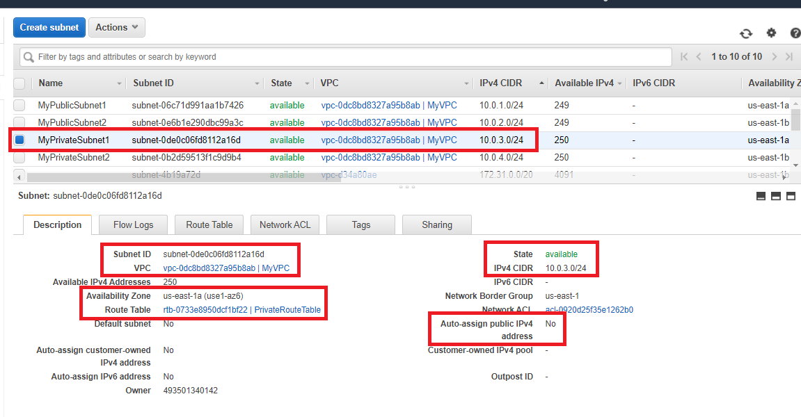

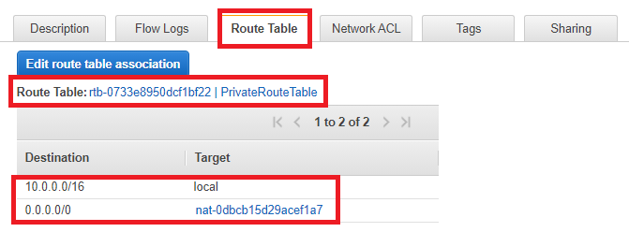

Fig. 4.3 Private Subnet 1

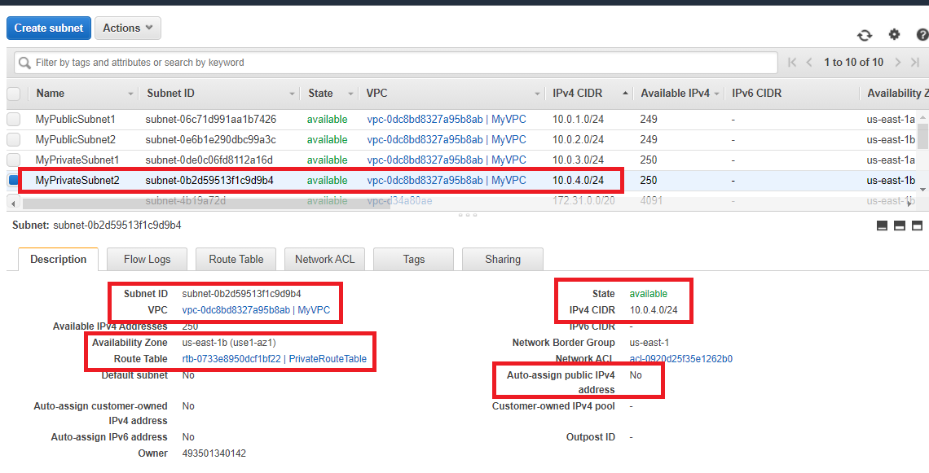

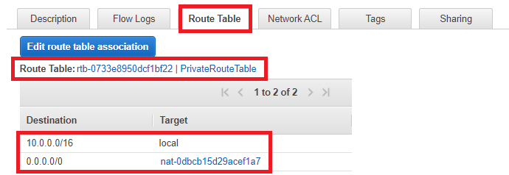

Fig. 4.4 Private Subnet 2

1. **Route Table creation:**

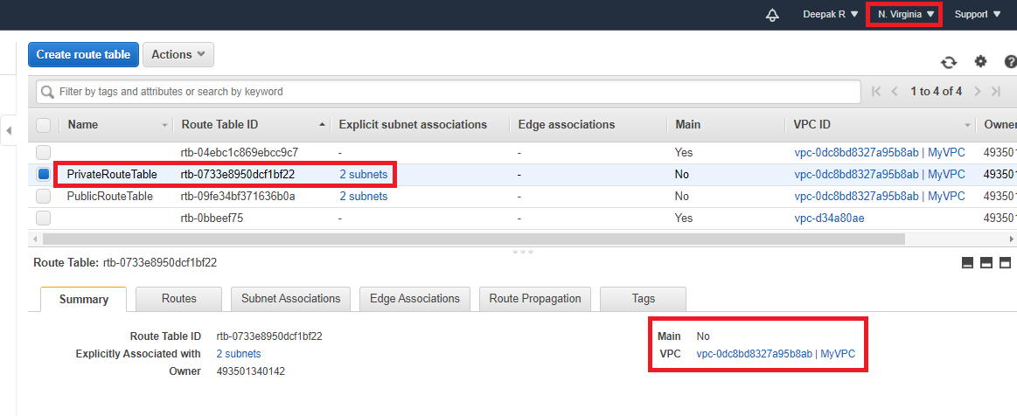

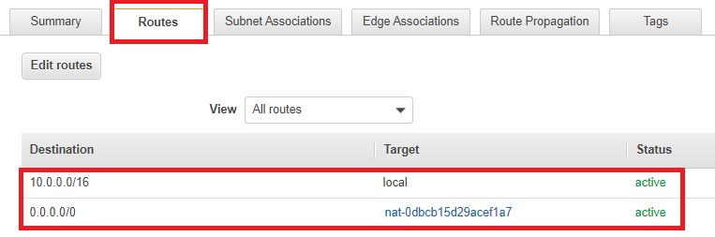

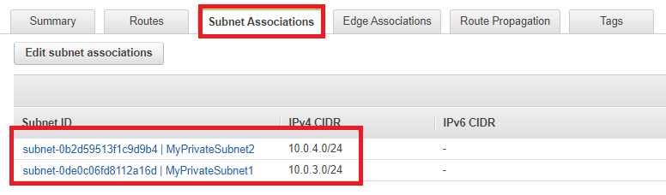

Fig. 5.1 Private Route Table

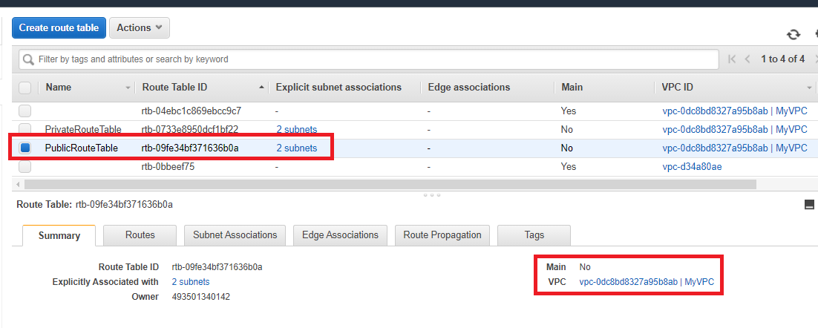

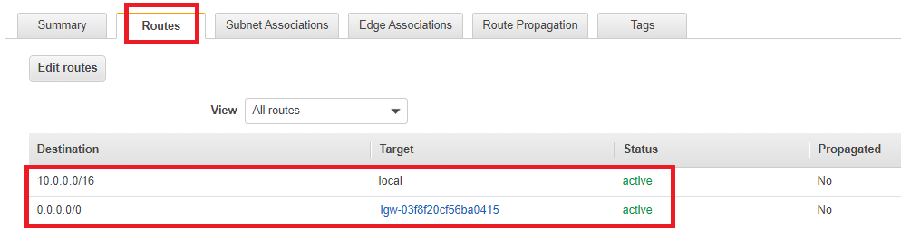

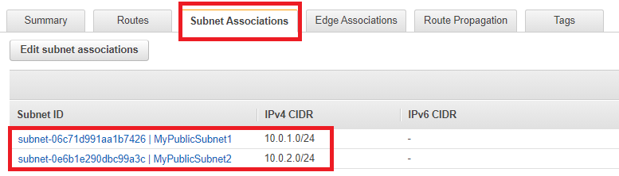

Fig. 5.2 Public Route Table

1. **Security Group creation:**

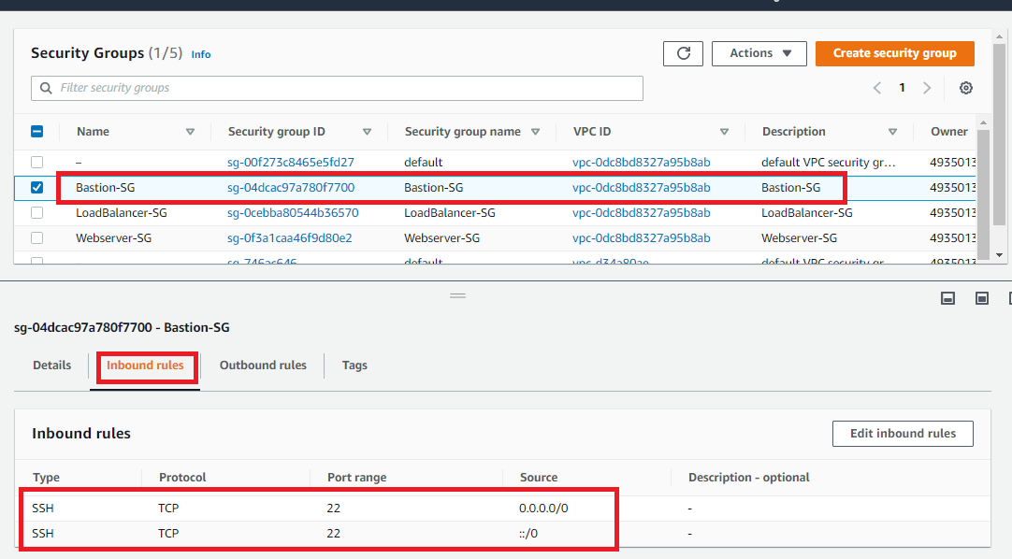

Fig. 6.1 Security group for bastion host

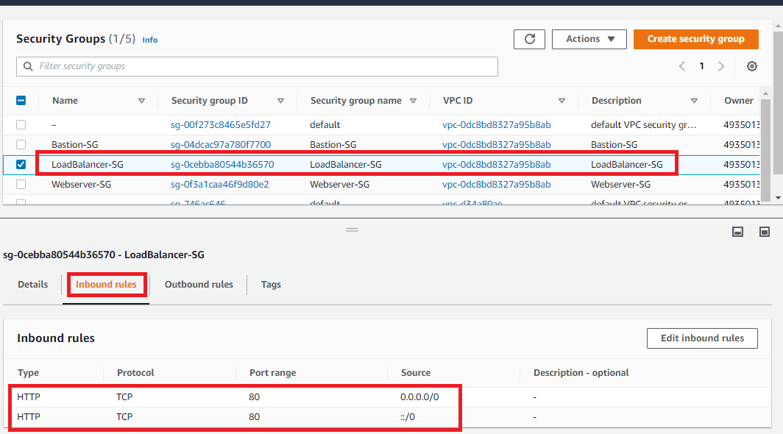

Fig. 6.2 Security group for Load balancer

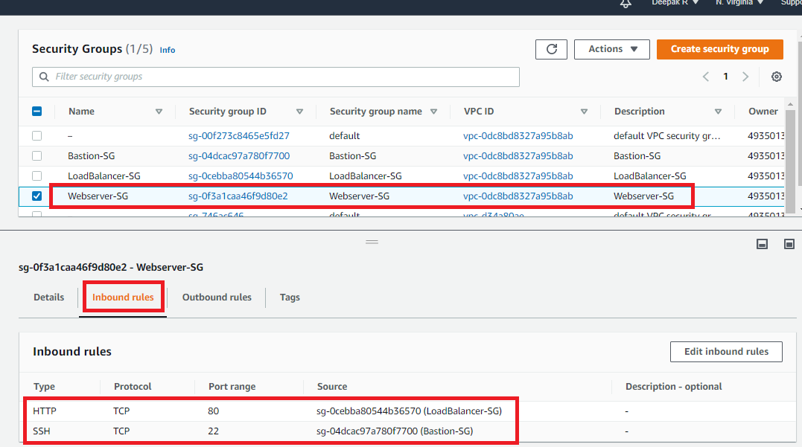

Fig. 6.3 Security group for Web-Server

1. **Instance creation:**

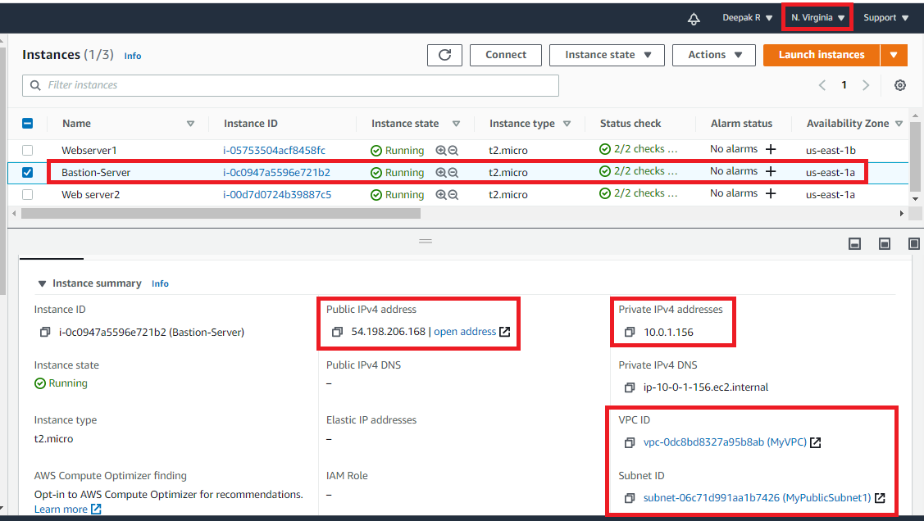

Fig. 7.1 Bastion-Server

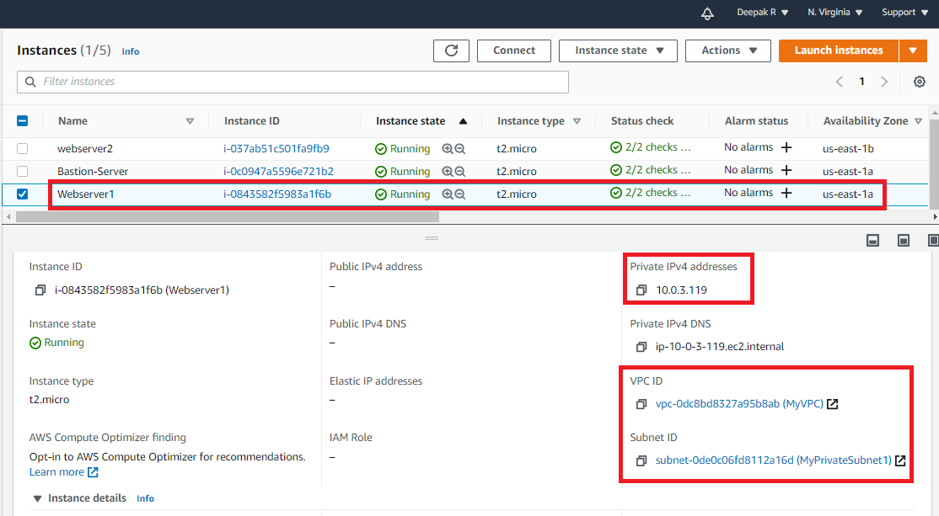

Fig. 7.2 Web-Server 1

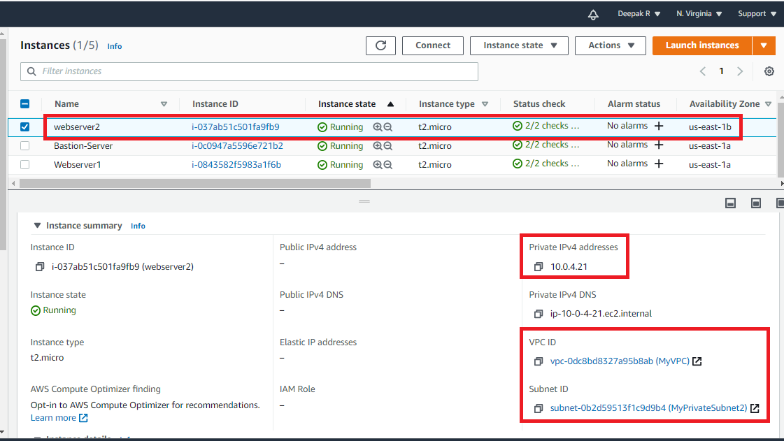

Fig. 7.3 Web-Server 2

1. **Load-Balancer creation:**

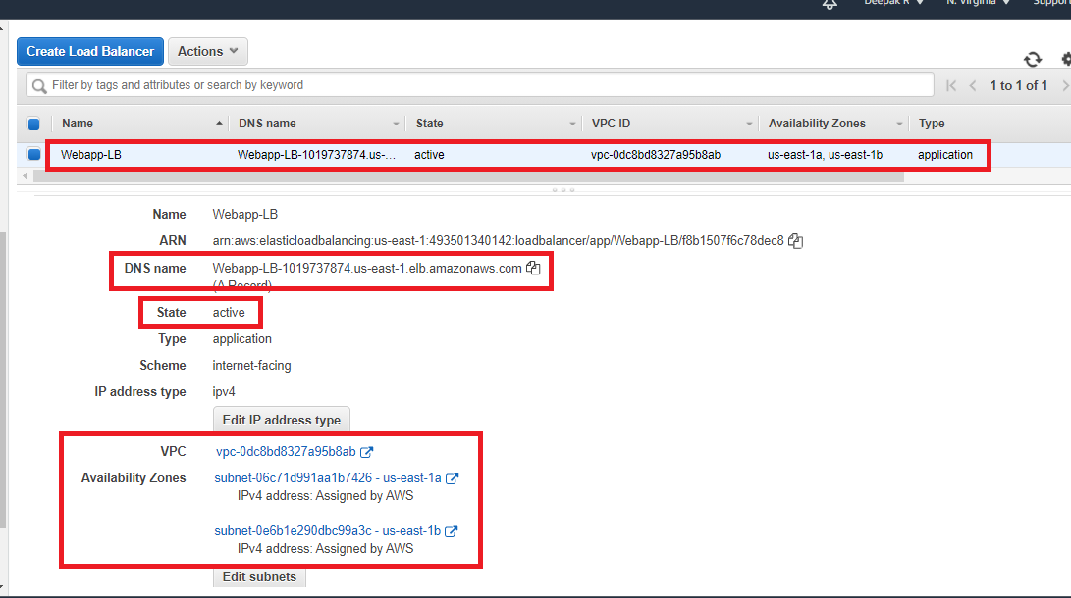

Fig. 8.1 Load-Balancer

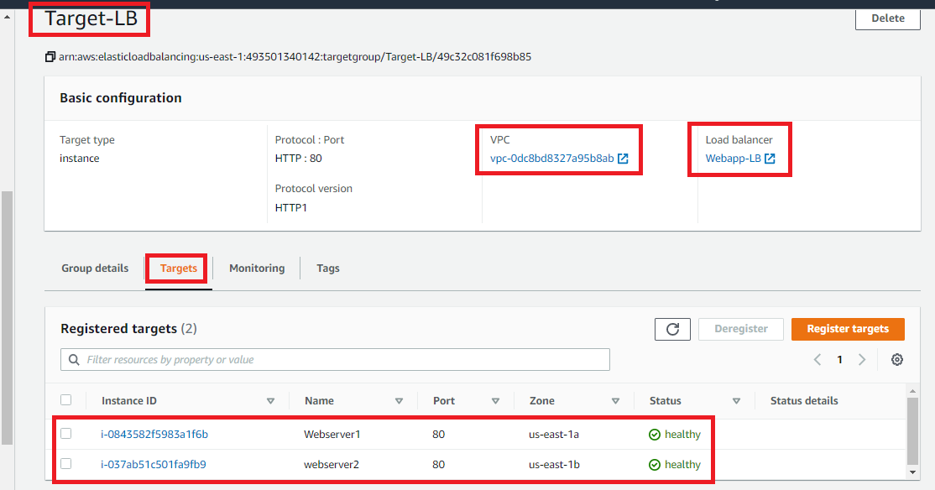

Fig. 8.2 Registered Target Groups with Healthy status

1. **Launching web server using DNS:**

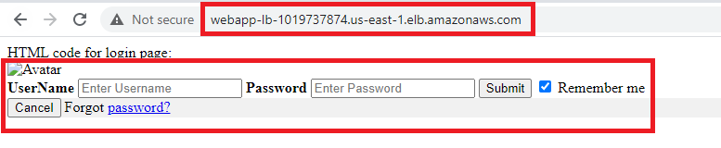

Fig. 9.1 Request handling by web-server 1

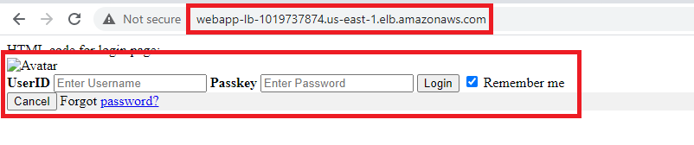

Fig. 9.2 Request handling by web-server 2

Test case for High Availability:

After stopping both the web-servers the status of web-server in target group changed to unused and we were not able to access web application using the DNS. After launching the DNS of load balancer, we are getting error as “503 service temporarily unavailable” and after terminating the instance getting error as” Site can’t be reached”

In Short:

After **Stopping** instance -- 503 service temporarily unavailable

**Terminating** Instance -- Site can’t be reached

By stopping one instance(web-server1) we are getting the response from the other running instance(web-server2).

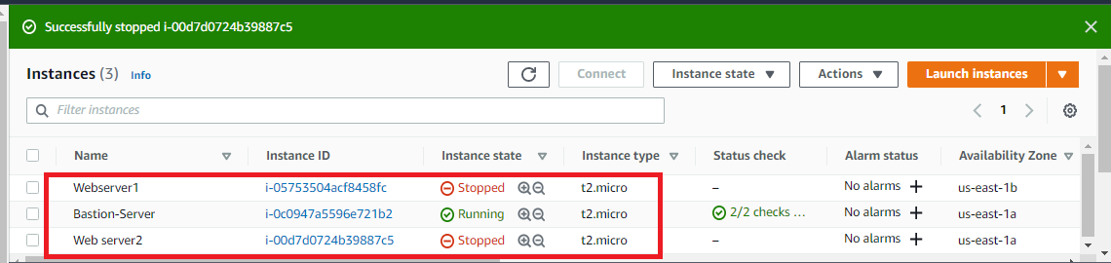

Fig. 10.1 Stopped instance

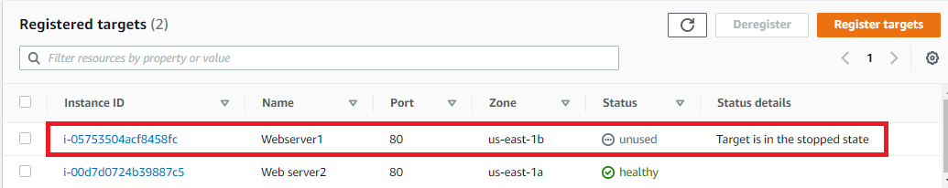

Fig. 10.2 Target status as ‘unused’



Fig. 10.3 After stopping both the instance